The nitrogen cycle:

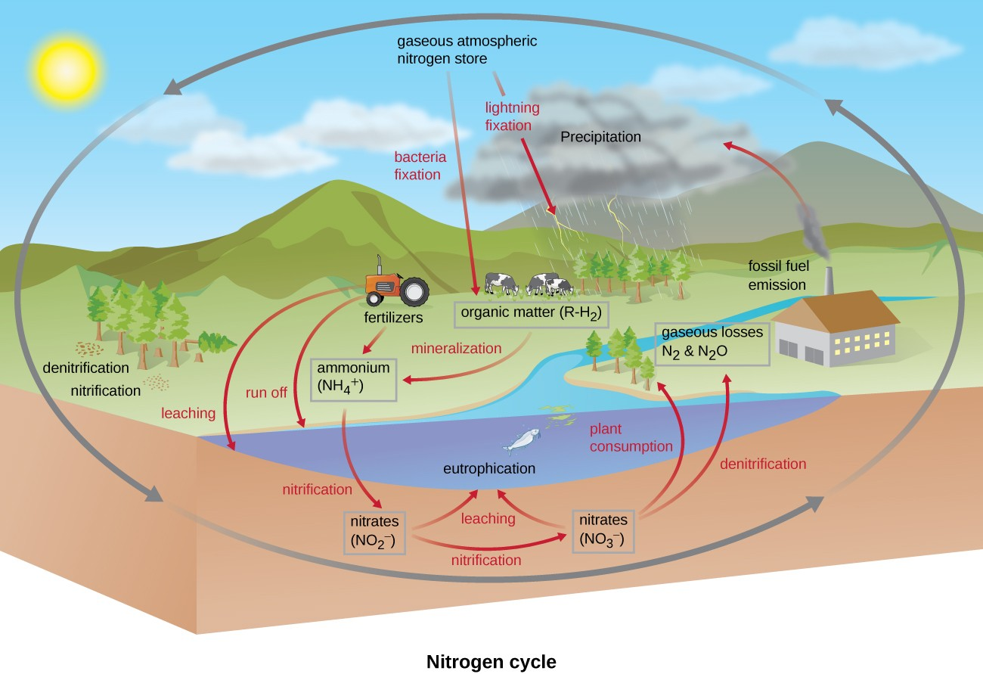
This figure summarizes the nitrogen cycle.
Nitrogen is the fourth most common element found in cells, making up approximately 12% of cell dry weight and includes microbially catalysed processes of nitrogen fixation, ammonium oxidation, assimilatory and dissimilatory nitrate reduction, ammonification and ammonium assimilation.
Human activity can release nitrogen into the environment by two primary means: the combustion of fossil fuels, which releases different nitrogen oxides, and the use of artificial fertilizers in agriculture, which are then washed into lakes, streams, and rivers by surface runoff. Atmospheric nitrogen is associated with several effects on earth’s ecosystems, including the production of acid rain (as nitric acid, HNO₃) and greenhouse gas (as nitrous oxide, N₂O), potentially causing climate change. A major effect from fertilizer runoff is saltwater and freshwater eutrophication: a process whereby nutrient runoff causes the excess growth of microorganisms, depleting dissolved oxygen levels and killing ecosystem fauna.
A similar process occurs in the marine nitrogen cycle, where the ammonification, nitrification, and denitrification processes are performed by marine bacteria. Some of this nitrogen falls to the ocean floor as sediment, which can then be moved to land in geologic time by uplift of the earth’s surface, becoming incorporated into terrestrial rock. Although the movement of nitrogen from rock directly into living systems has been traditionally seen as insignificant compared with nitrogen fixed from the atmosphere, a recent study showed that this process may indeed be significant and should be included in any study of the global nitrogen cycle.

Nitrogen Fixation:

In this process, the atmospheric nitrogen is chemically bound to form ammonia by bacteria and algae.The conversion of N₂ to ammonia or organic nitrogen,is restricted almost exclusively to microbes-bacteria(eubacteria, cyanobacteria and some actinomycetes). These occur in free-living state as well as in symbiotic associations with plants, both legumes and non-legumes. Ammonia is the first detectable product of nitrogen fixation. It is assimilated into amino acids,and subsequently synthesized into proteins and nucleic acids. The fixation of atmospheric nitrogen depends on the nitrogenase enzyme system, composed of nitrogenase and nitrogenase reductase. The active site of nitrgenase where reduction of nitrogen actually occurs, is associated with molybdenum- and iron- containing cofactors. Nitrogenase is very sensitive to oxygen and is irreversibly inactivated upon exposure to even low concentrations. In root nodules, the enzyme is protected by red pigment leghaemoglobin. The fixation of atmospheric nitrogen requires a high energy input(approx.30 ATP/N₂ fixed) and in terrestrial ecosystems largely dependent on the availability of relatively high levels of organic matter for use in respiratory generation of ATP. In soil, microbial fixation of atmospheric nitrogen is carried out by free-living bacteria(asymbiotic) and those in symbiotic association with plants (symbiotic).

Note: I have already discussed symbiotic nitrogen fixation in detail in the last semester so, not going in further detail about the same. Please refer to the last semester notes(for ‘symbiotic nitrogen fixation’).

Ammonification:

Microbes also carry out important transformations of organic and inorganic fixed forms of nitrogen. Nitrogen in organic matter is found predominantly in the reduced amino form, such as occurring in amino acids. Many microbes as well as plants and animals are able to convert organic amino nitrogen to ammonia- i.e., ammonification. Deaminases play an important role in this process. Microbial decomposition of urea results in the release of ammonia which is returned to atmosphere or may go to neutral aqueous environments as ammonium ions.

Nitrification:

Few organisms are capable of the process called nitrification, the process in which ammonium ions are initially oxidized to nitrite ions and subsequently to nitrate ions. Nitrification is an example of aerobic respiration. Both these steps are energy-yielding from which chemolithotrophs derive energy. Nitrification is carried out by autotrophic bacteria. Some heterotrophic bacteria and fungi are also able to oxidize inorganic nitrogenous compounds. In soil, Nitrosomonas is the dominant genus. Other autotrophic nitrifying bacteria are ammonia-oxidising, as Nitrosospira, Nitrosococcus and Nitrosolobus and nitrite-oxidisers, such as Nitrospira and Nitrococcus.

Nitrate Reduction:

Nitrate in environment can be leached to groundwater and surface waters. Besides this, nitrate can be taken up and incorporated into biomass by plants and microbes. It is first reduced to NH⁺₄ and then incorporated into biomass. This process is called assimilatory nitrate reduction or nitrate immobilization. Finally, microbes can utilize nitrate as a terminal acceptor in anaerobic respiration. There are two pathways for this dissimilatory processi) dissimilatory nitrate reduction to ammonium(end product), and (ii) denitrification, where a mixture of gaseous products including N₂ and N₂O is formed.

Denitrification:

The conversion of fixed forms of nitrogen to molecular nitrogen i.e., denitrification is another important but undesirable process in cycling that is mediated by microbes. Denitrification refers to microbial reduction of nitrate through various gaseous inorganic forms, to N_{2.} Some aerobic bacteria can use nitrate in place of oxygen as a final electron acceptor, reducing nitrate as a result of anaerobic respiration. Some, as E.coli are only able to reduce NO₃ to NO_{2,} but a variety of other bacteria are able to carry out subsequent anaerobic respirations, where NO₂ ion is reduced to N₂O gas and subsequently to molecular nitrogen. Some species of Pseudomonas, Moraxella, Spirillum, Thiobacillus and Bacillus are capable of denitrification. The return of nitrogen to atmosphere by this process completes the nitrogen cycle.

